Project 1
<Numbers game>

CIS-5 49006
Name: Arturo Aguilar
Date: 11/4/17
TABLE OF CONTENTS

INTRUDUCTION 1 1

HOW THE GAME WORKS 1 1 23

Object of the game
Rules of the game
APPROACH TO THE GAME 1

Introduction
“When you have mastered numbers, you
Will in fact no linger be reading number, any more
That you read words when reading books
You will be reading meaning.”
– W. E. B. Du Bois

When it comes to winning a game with numbers, the winner will always will calculate faster.

It is always fun to playing a game where you have to guess a random number, what makes it exiting is having a contender guessing your number. By playing a simple game as guessing a number the competition adds a time restrain and pressure to not lose the game. This competition makes both players play smarter. To calculate faster in order to bet the opponent.

HOW THE NUMBERS GAME WORK
Objective of the game:
To guess the opponents number before they guess yours.
RULES OF THE GAME:
Rule #1:
Each player will take turns guessing the opponents number.

MY APPROACH TO THE GAME
The user will create a number between 1 and 100.
The program will generate a number between 1 and 1000.
The user has 9 tries to guess the correct number.
The program will have 10 attempts to the user’s number.
The user will enter its guesses.
The program will get the user’s guess and will try to confuse the user by converting the number enter to a Roman numeral. Example: if the user enters the number 357, the game will display CCLVII.Then it will let the user know if the number is too high or too low.
The program will generate its guess for the user’s number.
If the user guesses the program’s number in less than 9 tries.
If the program guesses the user’s numbers in less than 10 tries.
After rendering the winner, the program will display the numbers the program used in the game and will display them in ascending order. use in sequence order.

Summary
Project size: about 261 lines.
Number of variables: about 68
Number of method: 18

This project includes many concepts that we learned for the chapters in the book and it still has the possibility to be extended and be improved.
Like adding a time limit to the user’s guess.

It took more time than it was estimated. At first, it was a simple guess game and it was very small. I needed to add more code and make the gam more interesting and challenging. I encounter to many dilemmas when I tried to implement the arrays and functions. I am not completely pleased with the project, but there is not enough time to get the project to its best potential.
The new concepts that I had to construct from the chapter we have cover is the sorting, arrays and functions.

Description

The point of this program is that how the roman numerals are integrated during the guessing game.
Pseudo Code

The program is started
Put in opening comments
Brings in system libraries
Brings in functions prototypes
Enter main, then declares variables
Generates random number the user will guess
Generates the random numbers the program will use to guess the user’s number
Sets the temporary number to be converted by the Roman numerals function
Display the name of the game and lets the user know of the rules of the game
User inputs its secret number
If the number is not between 1 and 100, the program will not accept it and ask the user to input a number between 1 and 100
User inputs a number to guess the program’s number
If the number is not between 1 and 1000, the program will not accept it and ask the user to input a number between 1 and 1000
Roman Function will convert the user guess to roman numeral
Case to identify the correct number for the hundreds from one to nine
Case to identify the correct number for the tenths from one to nine
Case to identify the correct number for ones from one to nine
Program will display the user secret number and the program’s guess
If the number the user guessed is greater than the random number
Display “too high”
If the number the user guessed is lower than the random number
Display “too low”
If the number the user guessed is not equal to the random number
Displays how many tires the user has left
If the number the user guessed is equal to the random number
Congratulates the user for winning the game
If the user exceeds the amount of tries
The game is over, the user is encouraged to try again
If the program guesses the user’s number
The program will notify the user and will ask the user to play the game
If the user guesses the program’s number
The program will notify the user and will ask the user to play the game
If the user decides to play again
The game will start over with new random numbers
If the user does not wan to paly again
The game will display the numbers the program use to guess the user’s name in ascending order
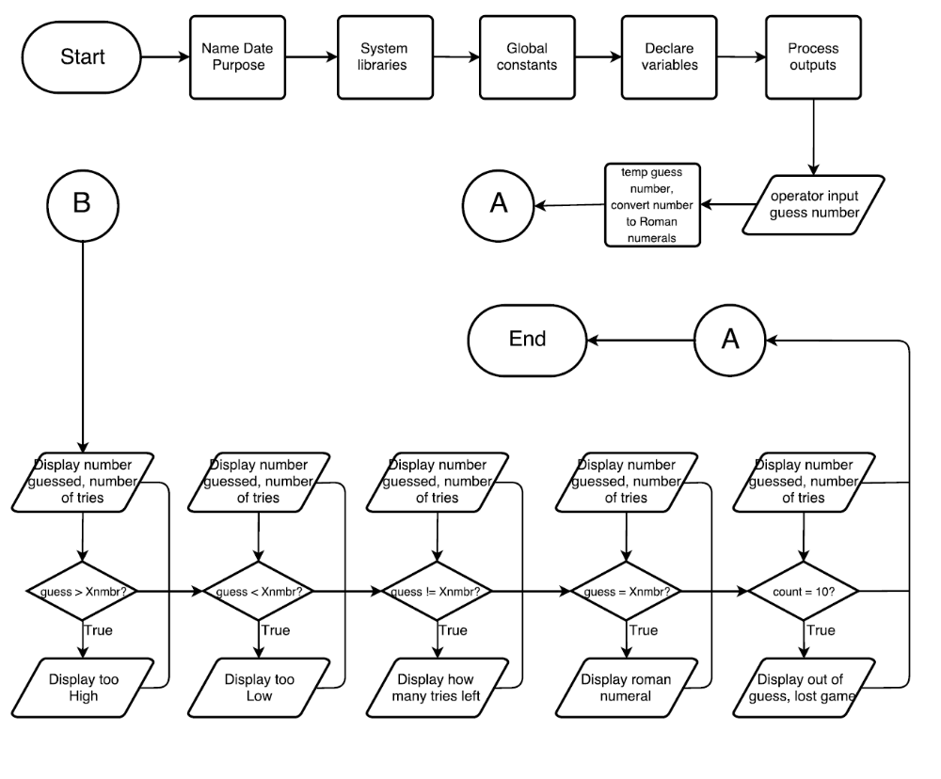
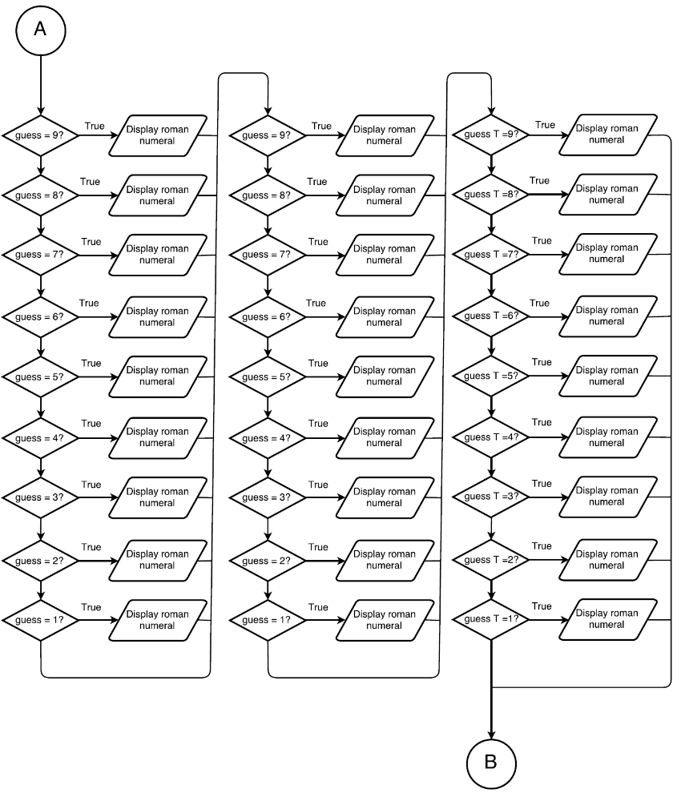

Major Variables
Type | Variable | Description | Location
Constant Integer | THSNDS | Number to recognize one thousand | Global Constant
 | HNDRDS | Number to recognize the hundreds number | Global constant
 | TENS | Number to recognize the tenths numbers | Global Constant
 | ONES | Number to recognize ones in numbers | Global Constant
Srand | Random Number | Generates a different number every time the program is run | Declare variables
Integer | Xnmbr | Number randomly generated between I and 999 | Declare variables
 | Guess | Number the user inputs every guess | Declare variables
 | Count | Number the program (zero)generates and adds one every time the user inputs guess | Declare variables
 | numTemp | Temporally number to keep Xnmbr as a single solid number | Map out outputs
 | Temp | Temporally number to keep guess as a single solid number | Map out outputs
Unsigned char | Nthsnds | Number to recognize the hundreds in a number | Map out outputs
 | NTens | Number to recognize tenths in a number | Map out outputs
 | NOnes | Number to recognize ones in a number | Map out outputs
Char | GuessH | Character to identify the hundreds of a number | Display outouts
 | GuessT | Character to identify the tenths of a number | Display outputs
 | GuessO | Character to identify ones of a number | Display outputs

Reference
- Dr. lehr’s Lectures & and Lab
- “Starting Out with C++: From Control Structures through Objects” Gaddis Tony. 8th edition (Textbook)
- Computer Lab
- https://github.com/ml1150258/LehrMark_CSC5_CIS5_Fall2017
- Internet research

Program

using namespace std; //Standard Name-space under which System Libraries reside
//Global Constants - Not variables only Math/Science/Conversion constants
const int THSNDS =1000;
const int HNDRDS = 100;
const int TENS = 10;
const int ONES = 1;

int main(int argc, char** argv) {
//Declare Variables
srand (time(0)); //random number generator
const int Xnmbr=rand() % 1000 + 1; //generates # between 1 and 100
int tries = 0, guess;
int count = 0;
unsigned char NThsnds, NHndrds, NTens, NOnes;

//Process or map the inputs to the outputs
int numTemp = Xnmbr;
NHndrds=numTemp/HNDRDS;
numTemp%=HNDRDS;
NTens=numTemp/TENS;
numTemp%=TENS;
NOnes=Xnmbr;

//Display/Output all pertinent variables
cout<<"Guess my number"<<endl;
while (guess != Xnmbr && count < 10)
{
cout<<"Enter a guess of my number"<<endl;
cin>>guess;
int temp = guess;// convert to Roman;
char guessH, guessT, guessO;
guessH=temp/HNDRDS;
temp%=HNDRDS;
guessT=temp/TENS;
temp%=TENS;
guessO=temp;
switch(guessH){
case 9: cout<<"CM";break;
case 8: cout<<"DCCC";break;
case 7: cout<<"DCC";break;
case 6: cout<<"DC";break;
case 5: cout<<"D";break;
case 4: cout<<"CD";break;
case 3: cout<<"C";
case 2: cout<<"C";
case 1: cout<<"C";
}
//Display The Number of 10's
switch(guessT){
case 9: cout<<"XC";break;
case 8: cout<<"LXXX";break;
case 7: cout<<"LXX";break;
case 6: cout<<"LX";break;
case 5: cout<<"L";break;
case 4: cout<<"XL";break;
case 3: cout<<"X";
case 2: cout<<"X";
case 1: cout<<"X";
}
//Display The Number of 1's
switch(guessO){
case 9: cout<<"IX";break;
case 8: cout<<"VIII";break;
case 7: cout<<"VII";break;
case 6: cout<<"VI";break;
case 5: cout<<"V";break;
case 4: cout<<"IV";break;
case 3: cout<<"I";
case 2: cout<<"I";
case 1: cout<<"I";
}
cout<<endl;
count++;
++tries;
if (guess > Xnmbr){
cout<<"To high!!"<<endl;
}
if (guess < Xnmbr){
cout<<"To low!!"<<endl;
}
if (guess != Xnmbr){
cout<<" nice try, you still got "<<10 - count<<" guesses"<<endl;
}
if (guess == Xnmbr){
cout<<"congratulations, you guess my number in "<<tries<<" tries"<<endl;
}
if (count == 10){
cout<<"you are out of guesses, maybe next time"<<endl;
}
}
switch(NHndrds){
case 9: cout<<"CM";break;
case 8: cout<<"DCCC";break;
case 7: cout<<"DCC";break;
case 6: cout<<"DC";break;
case 5: cout<<"D";break;
case 4: cout<<"CD";break;
case 3: cout<<"C";
case 2: cout<<"C";
case 1: cout<<"C";
}
//Display The Number of 10's
switch(NTens){
case 9: cout<<"XC";break;
case 8: cout<<"LXXX";break;
case 7: cout<<"LXX";break;
case 6: cout<<"LX";break;
case 5: cout<<"L";break;
case 4: cout<<"XL";break;
case 3: cout<<"X";
case 2: cout<<"X";
case 1: cout<<"X";
}
//Display The Number of 1's
switch(NOnes){
case 9: cout<<"IX";break;
case 8: cout<<"VIII";break;
case 7: cout<<"VII";break;
case 6: cout<<"VI";break;
case 5: cout<<"V";break;
case 4: cout<<"IV";break;
case 3: cout<<"I";
case 2: cout<<"I";
case 1: cout<<"I";
}

//Exit the program
return 0;
}

